

College of Engineering
Electrical and Computer Engineering Department CCEE 310 – Software Engineering

Project Report
ParkMe – Smart Parking Management Information System

Project Report Submitted by:
Hussien Ghaddar – 20240125 Anthony Abou Merhy – 20220568 Mariam El Chabab – 20240195 Mohammad Hassanieh– 20240109

Project Report Submitted to:

Ms. Amal El Arid

Spring 2026

Request for Information System Services
Executive Sponsor: Hussien Ghaddar
Organization: Beirut Municipality (Pilot Area Sponsor)
Title: Analyst

Submitted by: Hussien Ghaddar
Title: Analyst / Programmer
Request Date: 26/02/2026

Type of Service Requested:
New Development
Brief Company Background and History:
ParkMe is a proposed smart parking initiative for Beirut that combines IoT parking sensors/cameras, GPS mapping, and a centralized mobile/web platform. The goal is to provide real‑time parking availability, optional reservations, and cashless payment, while generating analytics for municipalities and parking operators. ParkMe supports smart‑city goals by reducing traffic congestion caused by drivers searching for parking, minimizing fuel waste, and improving urban mobility.

Brief Statement of Problems, Opportunities, or Directives:
Parking in Beirut is largely unmanaged and information is fragmented. Drivers spend significant time circulating to find a free spot, which increases congestion, fuel consumption, and stress. There is no reliable real‑time visibility of parking occupancy, and municipalities/parking operators do not have unified data for enforcement, planning, or pricing decisions. Manual payment and informal reservation practices also create disputes, revenue leakage, and poor user experience.

Brief Statement of Expected Solution:
Develop the ParkMe Smart Parking Management Information System to detect and publish parking occupancy in real time, guide drivers to available spots, optionally reserve a spot for a short time window, and support secure digital payment where applicable. The system will also provide dashboards and reports (utilization, peak hours, heat maps, revenue summaries) to support municipal planning and operator decision‑making.

Phase 1:
Requirements Analysis

Project Management
- Deliverability Period (From Scope Definition till System Installation): 3 months (13 weeks).

- Project Tasks: (add/remove tasks depending on your own project)
Task No. | Task Description | Task Duration (weeks) | Dependencies | Number of Staff Needed
A | Scope Definition | 1 | - | 2
B | Problem Analysis | 1 | A | 2
C | Requirements Analysis | 2 | B | 3
D | Use Case Analysis | 1 | C | 2
E | Data Modeling | 1 | C | 2
F | Process Modeling | 1 | D, E | 2
G | Implementation | 4 | F | 4
H | Testing / Validation | 2 | G | 3
I | Installation | 1 | H | 2
J | Documentation | 1 | G, H | 1

- Gantt Chart (Graphical Representation of Tasks):

Task | Task Description | W1 | W2 | W3 | W4 | W5 | W6 | W7 | W8 | W9 | W10 | W11 | W12 | W13 | W14
A | Scope Definition | 2
B | Problem Analysis |  | 2
C | Requirements Analysis |  |  | 3 | 3
D | Use Case Analysis |  |  |  |  | 2
E | Data Modeling |  |  |  |  | 2
F | Process Modeling |  |  |  |  |  | 2
G | Implementation |  |  |  |  |  |  | 4 | 4 | 4 | 4
H | Testing / Validation |  |  |  |  |  |  |  |  |  |  | 3 | 3
I | Installation |  |  |  |  |  |  |  |  |  |  |  |  | 2
J | Documentation |  |  |  |  |  |  |  |  |  |  |  |  | 1

Problem Statements

Brief Statements of Problem, Opportunity, or Directive | Urgency (Months till Deliverable) | Benefits (Money Saving) | Priority (Rank) | Proposed Solution
No real-time visibility of parking availability across busy Beirut zones, causing drivers to circulate randomly. | 4 | Reduces congestion and fuel waste by minimizing search time. | 1 | Deploy ParkMe platform with occupancy detection and live map of available spots.
High time waste and stress for drivers due to uncertainty and lack of guidance to free spots. | 3 | Improves driver productivity; reduces late arrivals and unnecessary trips. | 2 | Provide search filters, ETA estimates, and navigation to the nearest feasible spot.
No centralized data for municipalities/operators to plan capacity, pricing, or enforcement. | 6 | Enables data-driven planning and better utilization of existing infrastructure. | 3 | Build dashboards (utilization, peak hours, heat maps) and exportable reports.
Cash-based/manual payment and informal reservations lead to disputes and revenue leakage. | 4 | Increases payment traceability and reduces operational overhead. | 4 | Integrate secure digital payments, receipts, and reservation tickets.
Sensor/camera updates may be unreliable without monitoring, leading to user trust issues. | 5 | Maintains system credibility and reduces false availability incidents. | 5 | Implement sensor health monitoring, confidence scoring, and user feedback verification.

PROBLEMS, OPPORTUNITIES, OBJECTIVES AND CONSTRAINTS MATRIX

CAUSE AND EFFECT ANALYSIS |  | SYSTEM IMPROVEMENT OBJECTIVES
Problem or Opportunity | Causes and Effects | System Objective | System Constraint
Lack of centralized real-time parking availability data. | - Parking occupancy is not monitored centrally.  - Drivers rely on guessing, leading to unnecessary circulation.  - Increased congestion and fuel waste. | Create a unified database/service that stores live occupancy per spot/zone with timestamps and confidence scores. | - Limited budget for large sensor deployment.  - Pilot must start with limited zones.
Excessive search time for parking in peak areas. | - No guidance to nearest feasible spot.  - Peak-time demand exceeds perceived supply.  - Stress and late arrivals. | Provide map-based search with filters (price, distance, time limits), ETA, and navigation to selected spot. | - Depends on GPS accuracy and connectivity.  - Map API usage limits/cost.
Unreliable availability updates reduce user trust. | - Sensors can fail or be tampered with.  - False positives/negatives confuse users.  - Trust drops → low adoption. | Implement sensor health monitoring, anomaly detection, and user feedback reports to validate occupancy. | - Hardware maintenance needs coordination.  - Some false reports from users.
Manual payment and disputes with operators. | - Cash payments are untracked.  - Informal reservation claims cause conflicts.  - Revenue leakage and poor experience. | Integrate secure online payment, receipts, and reservation ticket/QR confirmation where applicable. | - Payment gateway integration fees.  - Compliance and security requirements.

CAUSE AND EFFECT ANALYSIS |  | SYSTEM IMPROVEMENT OBJECTIVES
Problem or Opportunity | Causes and Effects | System Objective | System Constraint
Municipality lacks analytics for planning/enforcement. | - No consolidated statistics on utilization.  - Decisions are made without evidence.  - Inefficient allocation of parking zones. | Generate dashboards and exportable reports (utilization, heat maps, peak hours, revenue summaries) for decision support. | - Limited historical data at launch.  - Advanced analytics may exceed semester scope.

Context Diagram (Draw using Visio Software)

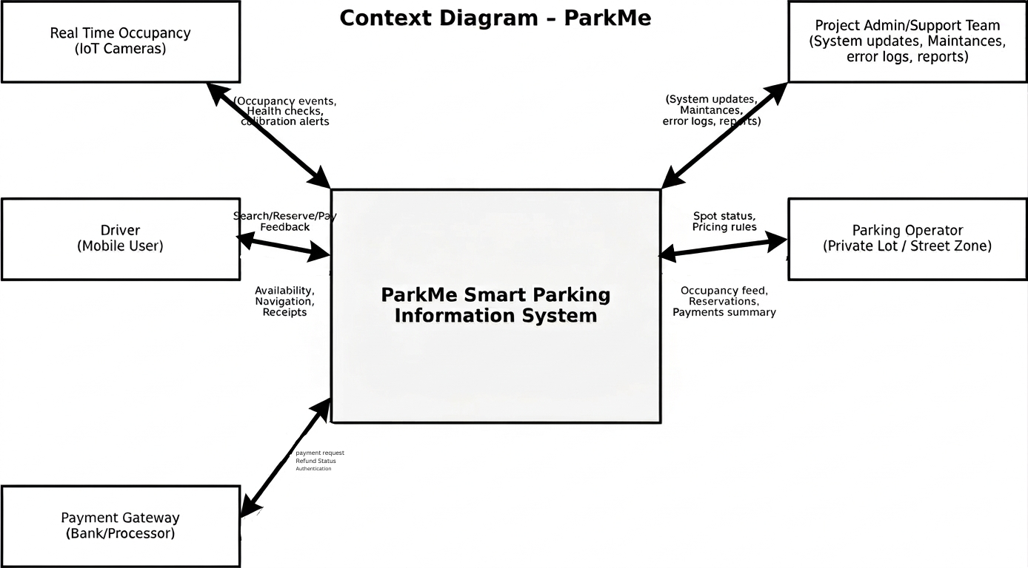
Tentative List of Functional Requirements

Requirement | Business /  System
1. A driver can create an account using phone number/email and verify it via OTP. | Business
2. A driver can log in/out and reset password securely. | Business
3. A driver can allow location access to view nearby parking zones on a map. | Business
4. A driver can search for parking by distance, price, zone, and time limit. | Business
5. A driver can view real-time availability status per zone and per spot (when spot-level sensors exist). | Business
6. A driver can view spot details (type, pricing, restrictions, max duration, confidence level). | Business
7. A driver can reserve an available spot for a configurable hold time (e.g., 5–10 minutes). | Business
8. A driver can cancel a reservation before arrival according to policy. | Business
9. A driver can start navigation to the selected spot using integrated map directions. | Business
10. A driver can check-in to a reserved spot using QR code / geofence confirmation. | Business
11. A driver can pay a parking fee through the app for participating operators/zones. | Business
12. A driver can receive a digital receipt/invoice after payment. | Business
13. A driver can extend parking time (where allowed) and pay additional fees. | Business
14. A driver can receive notifications for reservation expiry, parking expiry, and payment status. | Business
15. A driver can report an issue (spot incorrectly marked free/occupied, blocked spot, sensor error). | Business
16. A driver can rate the accuracy of a zone/spot after parking (feedback loop). | Business
17. A driver can view parking history (date, zone, duration, amount paid) with privacy controls. | Business
18. A driver can save favorite zones and set alerts for availability thresholds. | Business
19. A parking operator can register a parking facility/zone with capacity and pricing rules. | Business
20. A parking operator can define spot types (regular, disabled, EV, reserved) and restrictions. | Business
21. A parking operator can view current occupancy and reservations for their facility. | Business
22. A parking operator can approve/deny special reservations (optional workflow). | Business
23. A parking operator can configure allowed reservation hold time and cancellation penalties. | Business
24. A parking operator can view daily/weekly revenue and utilization reports. | Business
25. A parking operator can export transaction summaries to CSV/PDF. | Business
26. A municipality admin can define parking zones, rules, and permitted parking durations. | Business
27. A municipality admin can manage user roles (driver/operator/admin) and access rights. | Business
28. A municipality admin can view city-level dashboards (heat maps, peak hours, turnover rate). | Business
29. A municipality admin can configure dynamic pricing policies by zone/time (optional). | Business
30. A municipality admin can manage incident reports and sensor maintenance tickets. | Business
31. The system shall ingest occupancy events from IoT sensors/cameras with timestamps. | System

32. The system shall maintain an occupancy state per spot/zone and update it in near real-time. | System
33. The system shall compute a confidence score for availability based on sensor health and recency. | System
34. The system shall prevent double-booking by locking a spot during reservation hold time. | System
35. The system shall automatically release a hold if payment/check-in is not completed before expiry. | System
36. The system shall integrate with a maps API to compute routes and ETAs. | System
37. The system shall send push notifications/email/SMS based on user preferences. | System
38. The system shall integrate with a payment gateway to authorize, capture, and refund payments securely. | System
39. The system shall generate unique reservation tickets (QR/Code) and store their status. | System
40. The system shall record all key actions (search, reservation, payment, cancellation) with audit logs. | System
41. The system shall provide APIs for parking operators to update pricing and restrictions. | System
42. The system shall provide admin tools to configure zones, capacities, and policies. | System
43. The system shall generate analytics reports (utilization, revenue, accuracy) with filterable dates and zones. | System
44. The system shall support data export (CSV/PDF) for reports and transaction summaries. | System
45. The system shall maintain sensor inventory and track sensor health status (online/offline, battery, last seen). | System

Tentative List of Non-functional Requirements

Requirement
1. The system should load any main page (map/dashboard) within 2 seconds under normal network conditions.
2. The system should support at least 500 concurrent driver sessions in the pilot deployment without major slowdowns.
3. The system should be available at least 99.5% of the time excluding planned maintenance windows.
4. Users must authenticate and access must be controlled by role (Driver, Operator, Admin).
5. Passwords and tokens must be stored securely (hashed/secret-managed) and never in plain text.
6. All data transmissions must use HTTPS/TLS encryption.
7. The system should not store or expose any camera images containing people/plates; only occupancy states are stored.
8. The database must be backed up daily and recoverable within 4 hours after failure.
9. The system must validate inputs (phone number, payment amount, time windows) to reduce errors.
10. Reservation locking must respond within 1 second to avoid double booking.
11. The mobile/web UI must be responsive and usable on modern browsers and Android/iOS screens.
12. The system should log important actions (reservation create/cancel, payment success/fail, admin changes) with timestamp and user id.
13. The design should be modular so new zones, sensors, and payment providers can be added without major redesign.
14. The system should degrade gracefully during poor internet by showing last-known availability with timestamp and confidence indicator.

Phase 2:
Use-Case Analysis

Modeling System Requirements (Use-Case Glossary)

Use-Case Name | Use-Case Description | Participating Actors
Register / Login | A driver creates an account, verifies their identity via OTP, and authenticates access to ParkMe features. | Driver, System
Manage Account | A driver updates their profile information, saved payment methods, or notification preferences. | Driver, System
Search Parking | A driver searches for nearby parking zones or spots using filters such as location, price, and availability. | Driver, System
View Spot Details | A driver views restrictions, pricing, time limits, confidence score, and operator info for a selected spot or zone. | Driver, System
Reserve Spot | A driver places a temporary hold on an available spot and receives a reservation ticket with a QR code. | Driver, Parking Operator, System
Pay Parking Fee | A driver completes secure payment for a reservation or active session and receives a receipt. | Driver, Payment Gateway, System
Check-In to Spot | A driver confirms their arrival at the reserved spot by scanning the QR code or via GPS auto-detection. | Driver, System
Extend Parking Session | A driver requests additional time for an active parking session before it expires. | Driver, Payment Gateway, System
Cancel Reservation | A driver cancels an existing reservation before check-in and receives a refund if applicable. | Driver, Payment Gateway, System
View Parking History | A driver views a log of past reservations, payments, and parking sessions. | Driver, System
Receive Notifications | The system sends real-time alerts to the driver about reservation confirmations, expiry warnings, and payment receipts. | Driver, System
Rate & Review Spot | A driver submits a rating and optional review for a parking spot after completing a session. | Driver, System
Report Issue | A driver or admin submits a report about incorrect occupancy, a blocked spot, or a malfunctioning sensor. | Driver, Admin, System
Request Refund / Dispute | A driver raises a dispute about an incorrect charge or failed reservation and requests a refund. | Driver, Admin, Payment Gateway, System
Publish Parking Availability | A parking operator publishes available spaces in their facility so drivers can discover and reserve them. | Parking Operator, System
Manage Spots & Pricing | A parking operator creates or updates zones, capacities, spot types, pricing rules, and reservation policies. | Parking Operator, Admin, System
Monitor Sensors | A parking operator or admin views sensor status, uptime, last-seen time, and creates maintenance tickets. | Parking Operator, Admin, System
View Earnings & Reports | A parking operator views revenue earned from reservations and generates financial reports for their facility. | Parking Operator, System
Approve / Reject Operator | An admin reviews and approves or rejects a parking operator's request to list their facility on ParkMe. | Admin, System
Manage Users | An admin adds, suspends, or removes user accounts from the system. | Admin, System
Handle Dispute & Refund | An admin reviews driver-submitted disputes, validates claims, and processes refunds where applicable. | Admin, Payment Gateway, System
Analytics & Reports | An admin accesses system-wide dashboards showing occupancy rates, revenue trends, and usage statistics. | Admin, System
Generate Occupancy Heatmap | The system produces visual heatmaps showing parking demand and occupancy density across all zones. | Admin, System
Auto-Release Expired Hold | The system automatically releases a reserved spot if the driver does not check in before the hold expires. | System
Send Automated Reminders | The system dispatches SMS or push notification reminders to drivers about upcoming reservation expiry. | Driver, System
Process Payment | The system initiates and confirms secure payment transactions between the driver and the payment gateway. | Driver, Payment Gateway, System
Validate Sensor Data | The system continuously receives and validates occupancy data from parking sensors to ensure accuracy. | Parking Operator, System
Track & Log Sensor Status | The system monitors all connected sensors, logs uptime and failures, and flags devices needing maintenance. | Parking Operator, Admin, System

Modeling System Requirements (Use-Case Model Diagram)
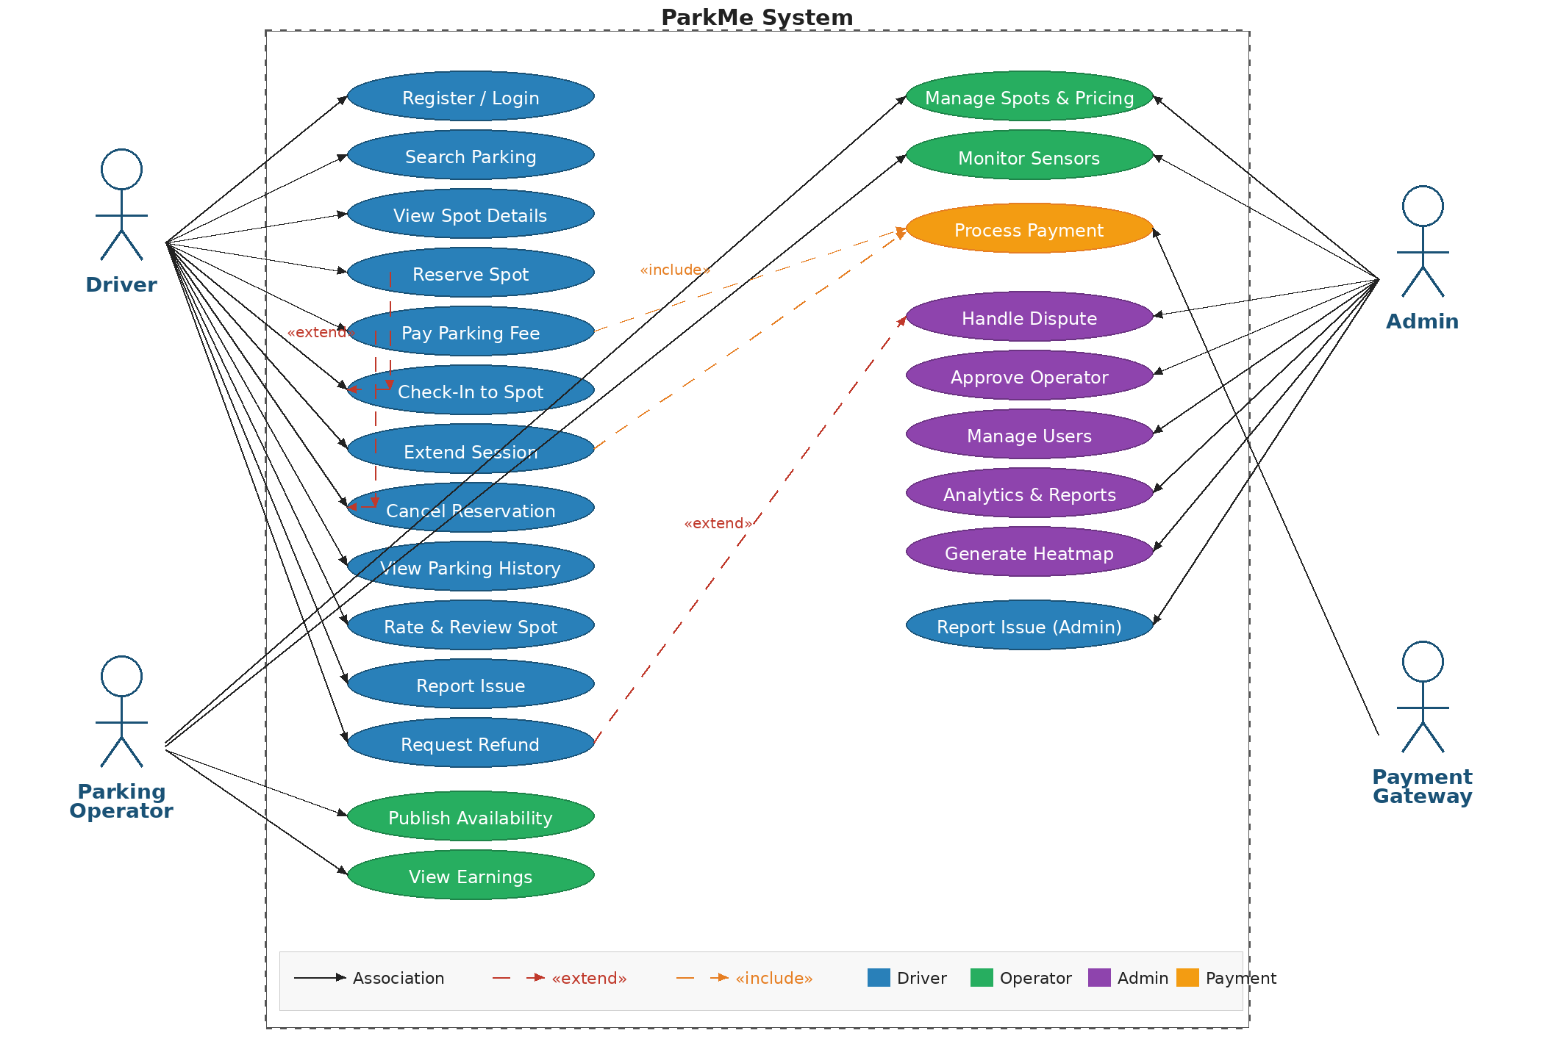

Modeling System Requirements (Use-Case Narrative)
Use-Case Name: | Reserve Spot | Use-Case Type: | External
Priority: | High (Rank 1)
Source: | Driver
Primary Business Actor: | Driver
Other Participating Actors: | System; Sensors / Cameras; Payment Gateway (if paid reservation); Parking Operator (notification)
Other Interested Stakeholders: | Drivers; Parking Operators; Admin
Description: | A driver selects an available spot/zone from the map and requests a reservation. The system verifies availability using recent sensor data, locks the spot for a short hold time, and issues a reservation ticket. If payment is required, the system initiates secure payment via the Payment Gateway. After confirmation, the driver receives a ticket/QR and navigation link. If the driver does not check in before expiry, the system releases the hold automatically.

Use-Case Name: | Manage Spots & Pricing | Use-Case Type: | External
Priority: | High (Rank 2)
Source: | Parking Operator / Admin
Primary Business Actor: | Parking Operator
Other Participating Actors: | System; Admin (policy constraints); Sensors / Cameras (spot inventory/health)
Other Interested Stakeholders: | Parking Operators; Drivers; Admin
Description: | The parking operator registers or updates a facility/zone, defines capacity and spot types, and configures pricing rules (hourly rates, peak pricing, discounts) and restrictions (max duration, disabled/EV spots). The system validates policy constraints set by the Admin, publishes changes to driver apps, and logs all changes for audit. The operator can enable/disable reservations per zone and set cancellation/hold rules.

Use-Case Name: | Analytics & Reports | Use-Case Type: | External
Priority: | Medium-High (Rank 3)
Source: | Admin
Primary Business Actor: | Admin
Other Participating Actors: | System; Parking Operators (data source); Sensors / Cameras (occupancy events)
Other Interested Stakeholders: | Admin; Parking Operators; Drivers
Description: | The admin generates dashboards and reports for selected dates and zones, including utilization rate, peak hours, heat maps, reservation conversion, revenue summaries (where applicable), and accuracy metrics (false availability reports). Reports support planning decisions such as adjusting zone boundaries, pricing policy, enforcement scheduling, and identifying locations requiring more capacity or better signage. Reports can be exported to PDF/CSV.

Modeling System Requirements (Sequence Diagram)

(Show the sequence diagram of the main event that contributes as much as actors as possible)

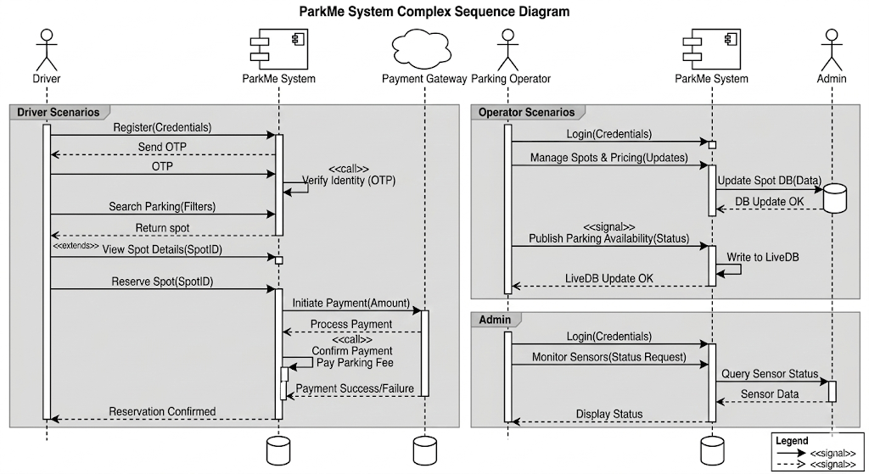

Phase 3:
Data
Modeling

Context Data Model

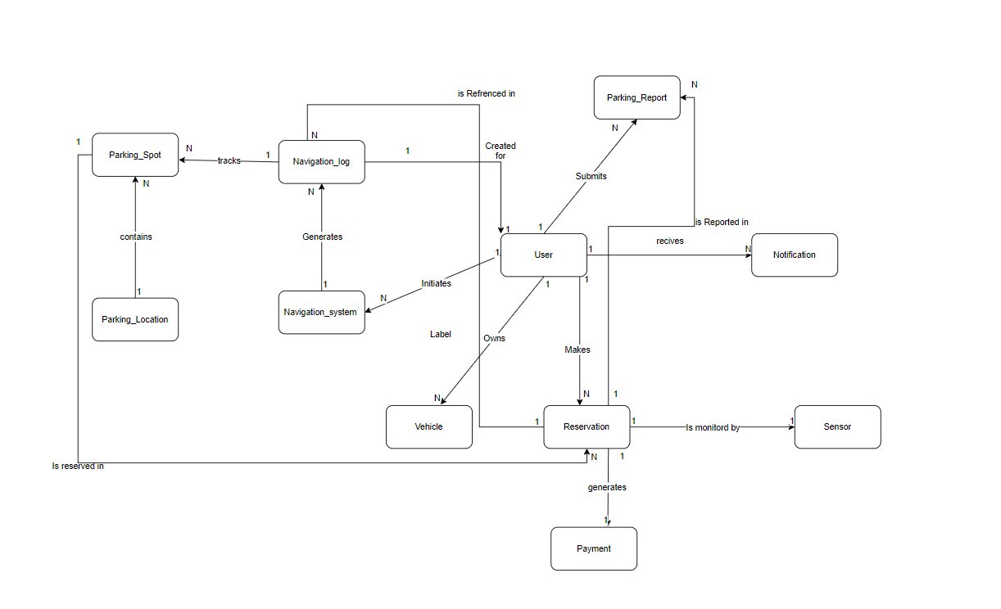

Key-Based Data Model

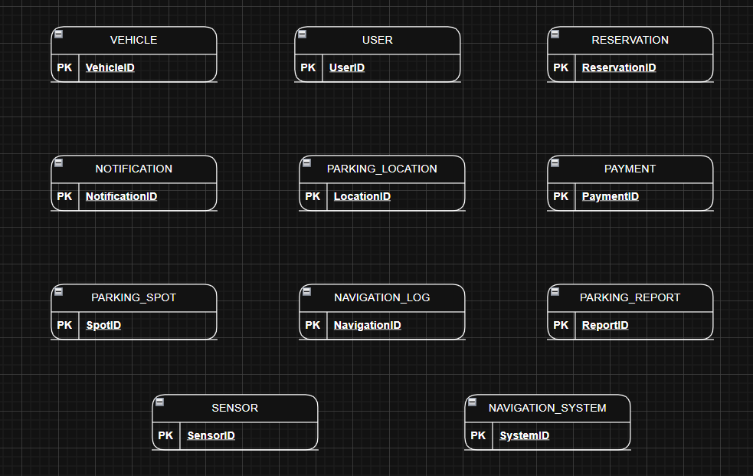

Fully-Attributes Data Model

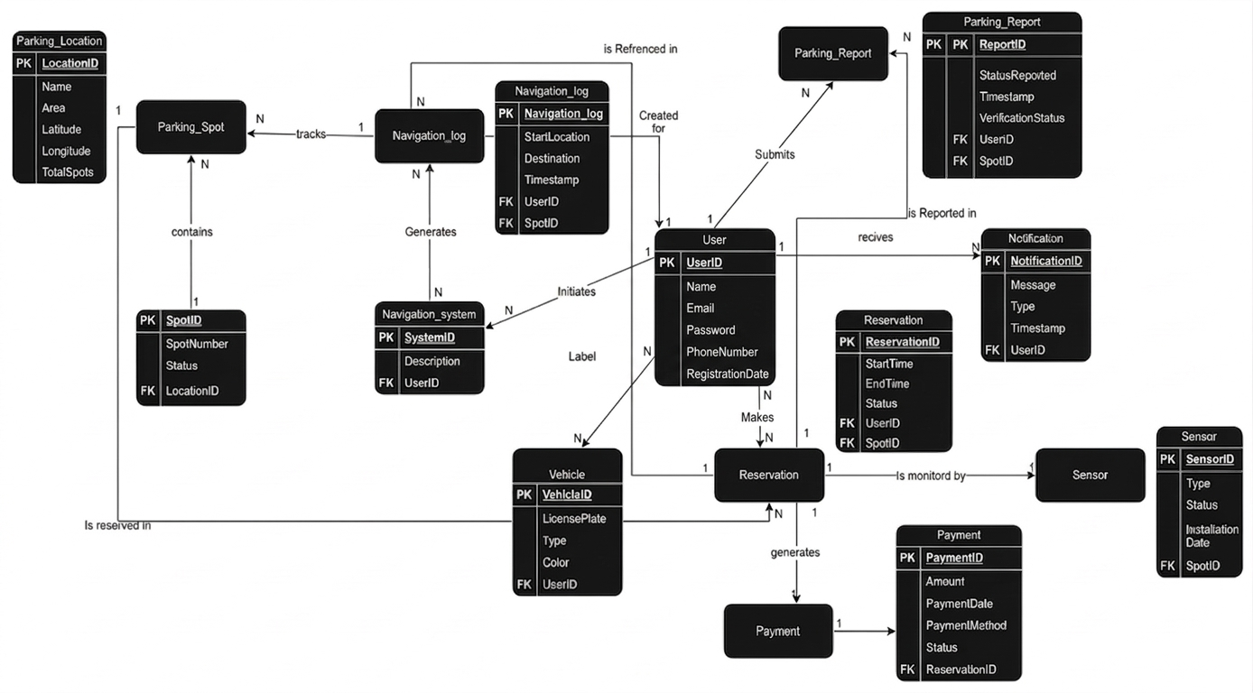

Phase 4:
Process
Modeling

Context Data Flow Diagram

Sensors / Cameras
Dashboards
Analytics Reports
Heat Maps
Peak Hour / Utilization Reports
Incident / Maintenance Information

Municipality Admin
Driver

Occupancy Events
Spot Status Updates
Sensor Health Status
Registration / Login Data
Search Request
Reservation Request
Payment Request
Issue Report / Feedback

Zone Rules
Parking Policies
User Role / Access Settings
Dynamic Pricing Policies

Available Parking Information
Spot Details
Reservation Confirmation
Navigation / Directions
Payment Receipt
Notifications / Alerts

ParkMe system

Payment Authorization Request
Refund / Charge Request

Parking Facility / Zone Data
Pricing Rules
Spot Types / Restrictions
Availability / Facility Updates

Occupancy Information
Reservation Information
Revenue Reports
Utilization Reports
Payment Gateway
Parking Operator

Payment Confirmation
Payment Status
Refund Status

Functional Decomposition Diagram

ParkMe System

User Management Subsystem
Parking Search & Navigation Subsystem
Reservation & Payment Subsystem
Operations & Monitoring Subsystem
Reporting & Analytics Subsystem

Generate Utilization Reports
Generate Revenue Reports
Generate Heat Maps / Dashboards
Register / Login User
Manage Profile
Send Notifications / Alerts
Search Parking
View Spot Details
Navigate to Spot
Reserve Spot
Cancel Reservation
Process Payment
Generate Receipt / Ticket
Manage Zones & Pricing
Collect Sensor Data
Update Availability Status
Monitor Sensors / Incidents

Use Case List

Actor | Event (Use-Case) | Trigger (Input(s)) | Responses (Output(s))
Driver | Registers an account in the ParkMe system | New user sign-up data | Create user account and send OTP verification/confirmation
Driver | Logs in to the system | Valid credentials (email/phone + password) | Authenticate user and grant access to ParkMe features
Driver | Manages account settings | Profile, payment method, or notification update request | Save and apply updated user preferences
Driver | Searches for nearby parking | Search request with location, price, and availability filters | Display matching available parking zones/spots
Driver | Views parking spot details | Spot/zone selection | Display pricing, restrictions, time limits, confidence score, and operator info
Driver | Reserves an available parking spot | Reservation request | Temporarily lock the selected spot and generate reservation ticket with QR code
Driver | Pays parking fees | Payment request | Process payment securely and generate digital receipt
Driver | Checks in to reserved spot | QR code scan or GPS auto-detection | Confirm arrival and activate parking session
Driver | Extends parking duration | Extension request | Update session duration and charge additional fees if applicable
Driver | Cancels a reservation | Reservation cancellation request | Release the reserved spot and process refund if applicable
Driver | Views parking history | History view request | Display log of past reservations, payments, and parking sessions
Driver | Rates a parking spot or submits feedback | Rating/review submission after session | Store rating and review, update spot quality records
Driver | Reports an issue with a spot or sensor | Issue report submission | Record the report and notify operator/admin for follow-up
Driver | Requests a refund or raises a dispute | Dispute submission with charge/reservation details | Log dispute and escalate to admin for validation and refund processing
Parking Operator | Publishes parking availability | New facility/zone listing information | Create zone/facility record and make it discoverable to drivers
Parking Operator | Manages spots, pricing, and restrictions | Updated zone rules, capacity, or pricing data | Update zone configuration and publish changes to the platform
Parking Operator | Monitors sensor status | Sensor/occupancy status request | Display sensor uptime, last-seen time, and flag devices needing maintenance
Parking Operator | Views earnings and utilization reports | Report generation request | Generate revenue and utilization reports for the facility
Admin | Approves or rejects a parking operator | Operator registration review request | Update operator status and notify them of the decision
Admin | Manages user accounts | User management action (add/suspend/remove) | Apply changes to user account and update system records
Admin | Handles disputes and processes refunds | Dispute review/action request | Validate driver claim and process refund where applicable
Admin | Accesses analytics and dashboards | Analytics/report request | Generate system-wide dashboards with occupancy rates, revenue trends, and usage stats
Admin | Generates occupancy heatmap | Heatmap generation request | Produce visual heatmap of parking demand and density across all zones
Admin | Manages incidents and maintenance tickets | Incident/maintenance action request | Update ticket status and notify responsible staff
Sensors / Cameras | Detect a change in occupancy status | Occupancy event from sensor/camera | Update parking spot availability in near real-time
Sensors / Cameras | Report sensor health data | Sensor status event | Update health/maintenance status of the device and log any failures
Time | Reservation hold expires | Reservation expiry time reached | Automatically release the held spot and update availability
Time | Parking session expires | Session expiry time reached | Notify driver and mark session as expired
Payment Gateway | Returns payment transaction status | Payment authorization/capture result | Update transaction status and notify the driver of outcome

Event Data Flow Diagram

